9

October 19, 2022
8:00 am to 5:00 pm | Virtual Pre-Conference (8 hours)

October 20, 2022
8:00 am to 4:45 pm | Fraud Conference Day 1 (8 hours)
4:45 pm – 6:30 pm | Houston ACFE and IIA Networking Reception  Reception open to all Houston ACFE Chapter members and IIA members, conference attendees, vendors and speakers

October 21, 2022
8:00 am to 5:00 pm | Fraud Conference Day 2 (8 hours)

Location
Houston ACFE Chapter
www.houstonacfe.org
Norris Conference Center | Norris Conference Centers - Houston CityCentre - Norris Centers  Norris Centers – Houston  816 Town & Country Blvd.  Suite 210  Houston, Texas 77024  (713) 590-0950
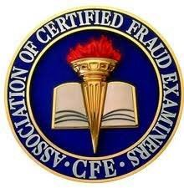
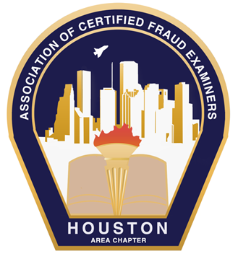
TRAVEL AND HOTEL
The conference is at the Norris Conference Center, located at 816 Town and Country Blvd, Houston, TX 77024, (713) 590-0950.
This is located on the west side of Houston, right off Interstate 10 West (also known as the Katy Freeway). The area is known as Citycentre and nearby is also known as Town & Country.
Airport Options:
There are two airports in Houston, Hobby Airport (HOU) and Bush Intercontinental (IAH). Hobby airport is 30 miles from the Norris Conference Center. IAH is also 30 miles from the Norris Conference Center. We suggest allowing at least one hour for travel time to the airport as Houston traffic can be very congested.
SuperShuttle is an option for airport transfers. The link to the Supershuttle website is https://www.supershuttle.com/locations/houston-iah-hou/.
Uber, Lyft, and Taxis are also good options for travel within Houston.
Private cars can be rented at both airports. Parking is free for the conference in the Norris Conference Center garage on site.
Information regarding travel to Houston can be found on the Greater Houston Convention & Visitors Bureau website here: https://www.visithoustontexas.com/travel-planning/
Continental breakfast, lunch and snacks for all sponsors and attendees will be provided as part of the conference.
Lodging Options
The Norris Conference Center is in the retail/conference center called CityCentre. The link to the conference center website is here.
https://norriscenters.com/norris-conference-centers-houston-citycentre/
Nearby are a variety of hotels:
The Moran at CityCentre Hotel is adjacent to the Norris Conference Center, located in the same CityCentre complex. As of the writing of this brochure (June 12, 2022), Houston ACFE was quoted a rate of $288 per night for a Texas King Room. With hotel taxes this will be $310.74 per night. The rate will vary as the conference gets closer. Please call the hotel directly at (713) 973-1600 to make a reservation.
Sonesta Simply Suites,10503 Town & Country Way, Houston, TX 77024, is located a few blocks (a 5-minute walk) from the Norris Conference Center. They have offered a guaranteed rate of $80 (plus tax) for the Studio Suite and $95 (plus tax) per night for the One Bedroom Suite. To book this rate, please contact the hotel directly at (713).464.2677. Their website is https://www.sonesta.com.
Hilton Garden Inn Houston Energy Corridor located at 12245 Katy Freeway, Houston, Texas, 77079, is a 5-minute drive from the Norris Conference Center. The website link is Hilton Garden Inn Houston Energy Corridor. The direct line to the hotel is 281-531-0220. They have offered a guaranteed rate of $119.00 per night + tax on regular rooms (king bed or queen beds) including breakfast. For a 2 bedroom they have offered a rate of 129.00 per night plus tax. A hotel shuttle will be available in the morning at 7:30 am to take guests to the conference and at the end of the day to return to the hotel. This shuttle service is on a first come first serve basis. To book this hotel, please contact Theresa.Robertson@hilton.com or by phone 281-741-6491. The Hilton has a reserved block of rooms for the conference.
There are numerous other options for lodging in the area.
AGENDA/SCHEDULE* Subject to change due to the vagaries of human existence…
ALL VIRTUAL SESSIONS ON 10/19 WILL BE ZOOM WEBINARS
Virtual Pre-Conference 10/19/2022 – 8 Hours CPE

Date | Time | Speaker | Company/Individual | Topic
10/19/2022 | 8:00 – 8:10 am | Houston ACFE |  | Opening Remarks
10/19/2022 | 8:10 am – 9:00 am (1 CPE) | Drew Pfeifer | Ethos Risk, FL | Privacy Rights in Interviews
10/19/2022 | 9:10- 10:00 am (1 CPE) | Annerine Dean, CFE CAMS | Pohlmann Group, Germany | Fraud and Monitorship in Audit
10/19/2022 | 10:10 - 11:00 am (1 CPE) | Melissa Ortiz | Producers National | Why are my insurance rates so high? The connection between Fraud and Insurance
10/19/2022 | 11:10 - 12:00 pm (1 CPE) | Shannon Harjer, CPCU, AIC, ARM | Quincy Mutual Group, MA | Finding Your Purpose Through Mentoring
10/19/2022 | 12:00 - 1:00 pm | Lunch on your own (Break)
10/19/2022 | 1:00 pm - 1:50 pm  (1 CPE) | Jorden Brewster CFE ACFS | Speaking as an Individual, London, UK | Whistleblowing: the key to unlocking the leadership door
10/19/2022 | 1:50 pm - 2:00 pm | Sponsor Introductions
10/19/2022 | 2:10- 3:00 pm (1 CPE) | Dawn LeCrone, CAMS | Nationwide Financial | Elder Fraud as Financial Crime, Case Studies and Best Practices
10/19/2022 | 3:05– 4:00 pm (1 CPE) | Amanda Dupont, CAMS & Zac Sheldon | Thomson Reuters | Best Practices – spotting and stopping Identity Fraud
10/19/2022 | 4:05 pm – 4:55 pm (1 CPE) | Ellen Smith, J.D. | Amalie Trade Compliance Consulting | Russian Sanctions – Are they Effective? What is the Latest?
10/19/2022 | 4:55 pm | closing remarks

IN PERSON CONFERENCE STARTS 10-20-2022 AND RUNS THROUGH 10-21 AT NORRIS CONFERENCE CENTER, HOUSTON TX
Date | Time | Speaker | Organization | Topic
10/20/2022 | 8:00 – 8:15 am  Red Oak | Houston ACFE Board |  | Opening Remarks
10/20/2022 | 8:15 - 9:55 am (1 hr. 40m) - General session (2 CPE)  Red Oak | Chris Ekimoff and Leo Munoz | RSM US | Into the Woods: Plotting a Course for a Successful Internal Investigation
10/20/2022 | 9:55 am - 10:10 am | Break
10/20/2022 | 10:10 - 11:00 am Red Oak – (1 CPE) | Keith Kahl, CFE, CPA, CIA, CRMA, CGMA | Kahl Professional Services, TX | How to Ethically Succeed in Life, Investigations and Career*
10/20/2022 | 10:10 - 11:00 am  Magnolia – (1 CPE) | Sophia Carlton, CFE | Accenture | Recession Strikes, Fraud Spikes: Recession-Proof Your Fraud Defenses
10/20/2022 | 11:10 - 12:00 pm  Magnolia (1 CPE) | Andrew Taylor, CFE | Veritas Technologies LLC, TX | Reducing the Risk of Fraud in your Distribution Channel
10/20/2022 | 11:10 - 12:00 pm Red Oak (1 CPE) | Michael T. Dawkins and Sean Sarsfield, CFE, CPA, CFF, CVA | FORVIS and Baker, Donelson, Bearman, Caldwell & Berkowitz, P.C. | Best Practices for Conducting Internal Investigations
10/20/2022 | 12:00 - 12:40 pm Magnolia | LUNCH
10/20/2022 | 12:40 - 12:55 | Houston ACFE Board |  | Announcements
10/20/2022 | 12:55 – 1:00 pm | Break
10/20/2022 | 1:00 pm - 2:40 pm Magnolia | Special Agent Dimitri Wills & Shelby Janysek, Forensic Accountant FBI | FBI, Houston TX | Business Email Compromise Investigation
10/20/2022 | 1:00 - 2:40 pm Red Oak | Jessica Sanderson, JD | Volkov Law Firm, San Diego, CA | Anti-Corruption and Sanctions Compliance
10/20/2022 | 2:40 - 3:00 PM | Ice Cream Social
10/20/2022 | 3:00 pm - 4:40 pm  Red Oak | Rick Roybal, CFE | Matador Resources, TX | How a Leaky Password Shut Down a Pipeline: The Colonial Pipeline Ransomware Attack
10/20/2022 | 3:00 pm – 4:40 pm Magnolia | Jorge Monteiro CFE | Detroit MI | Lean Case Management: Increasing Investigative Agility
10/20/2022 | 4:40 PM | Attendees break
10/20/2022 | 4:45 - 6:30  Magnolia | All Chapter Members of Houston ACFE and IIA, Vendor Sponsors, and Speakers are invited to attend |  | Networking Social IIA & Houston ACFE, light refreshments provided

 | Time | Speaker | Organization | Topic
10/21/2022 | 8:00 – 9:40 am (General Session)  Red Oak | Robert Berry, ISACA & Jo Erven, CPA, CFE | ThatAuditGuy.com, FL and Audit. Consulting. Education. LLC, CO | Friday Fraud Podcast, Live!  (This session not eligible for TCOLE)
10/21/2022 | 9:40 am - 10:00 am | Break & Networking
10/21/2022 | 10:00 - 10:50 am Magnolia | Warren Rojewski, CFE | Nationwide Insurance, MI | Fraud Indicators in the Self-Service World: email compromises, account take overs and more
10/21/2022 | 10:00 - 10:50 am  Red Oak | Thomas Feray, CFE | Action for Integrity, Montreal, CA | Creating and developing a culture of psychological safety and ethics for investigators*
10/21/2022 | 11:00 – 11:50 am  Magnolia | Amy Nofziger, CFE | AARP | Elder Fraud, Changing the Narrative: Stop Blaming the Victim
10/21/2022 | 11:00 – 11:50 am  Red Oak | Paul Pettit | Revenew | Construction Fraud: You Make the Call
10/21/2022 | 11:50 – 12:30 pm  Magnolia | Lunch
10/21/2022 | 12:30 - 12:50 pm  Magnolia | Houston ACFE Board |  | Remarks
10/21/2022 | 12:50 - 1:00 pm | Move to Rooms/break
10/21/2022 | 1:00 - 2:40 pm  Magnolia | Jason Zirkle, CFE, CAMS | ACFE National Organization | A Case Study in Ethics and Embezzlement
10/21/2022 | 1:00 - 2:40 pm  Red Oak | Dan Ramey, CFE, CPA, LLC | Houston Financial Forensics & University of Houston | Cryptocurrency Fraud
10/21/2022 | 2:40 - 3:00 pm  Magnolia | Ice Cream Social Break
10/21/2022 | 3:00 – 3:50 pm  Red Oak | Marta Cadavid, CAMS, CFE, CHTI, AMLCA | NOFRAUD LATAM LLC | Using The Fraud Triangle Analytics to predict, prevent and detect misbehaviors
10/21/2022 | 4:00 – 4:50 pm  Red Oak General Session | Dr. Oscar Harvin, CPA, CFE | Sam Houston State University, TX | Presentation: Is Robin Hood Just a Fairy Tale
10/21/2022 | 4:50 – 5:00 | Houston ACFE |  | Closing Remarks

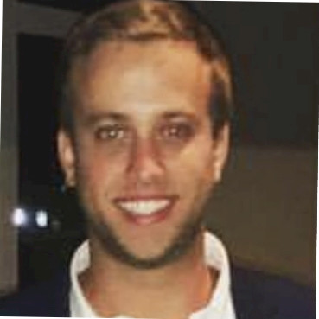
Speaker: Drew Pfeifer, Ethos Risk

Presentation: “An Individual’s Right to Privacy”

Description: This course will outline the rights to privacy an individual being investigated can expect, along with the rights and responsibilities of the investigating entity to perform due diligence while investigating. It will identify areas of potential bad faith and inform investigators of proper investigative behaviors to ensure the needs and rights of the subject and the company are properly met.

Bio: Account Manager with Ethos Risk Services. Drew has worked for Ethos for 10 years. He has spent time overseeing Surveillance and Field Operations for Ethos, as well as conducting desktop investigations. Drew graduated from Florida State University and currently resides in St. Petersburg, FL.
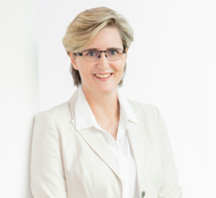
Speaker: Annerine Dean, CFE, CAMS
Pohlmann & Company

Presentation: “Fraud and Monitorship in Audit”

The presentation will explain why “standard audit” approached often fail to detect fraud and corruption and how fraudsters can take advantage of this method. I will also explain how you can approach this process (audit and transaction testing) from a different perspective to hopefully identify and detect potential fraud or areas within your process where there are “gaps” and/or opportunities that could potentially be exploited by fraudsters. I will also provide some examples on how fraudsters can take advantage of an inadequate control environment or where management oversight activities are lacking. Finally, I will also provide some general insights gained from the Monitorships.

Bio: Proactive, results-oriented ethics and compliance consultant with extensive experience leading and driving successful ethics and compliance initiatives. Strong work ethic which translates into a commitment towards quality, teamwork, and trust building. Audit and consulting experience which includes both external and internal clients. Able to build strong business relationships with employees at all levels within an organization, as well as with global business units, transcending language and cultural barriers. Keen enthusiasm for staying abreast on the latest developments and acquiring a deep understanding of an organization and its challenges and vulnerabilities within a chosen industry, in order to provide tailored compliance guidance and efficient, effective solutions to mitigate risks.

Speaker: Shannon Harjer, CPCU, AIC, ARM
Claims Vice President - Quincy Mutual Group

Presentation: “Finding Your Purpose Through Mentoring”

Description: Recognizing your contributions, strengths, passions and aspirations through consistent, progressive mentoring unlocks your utmost career potential. Finding a circle of mentors assisting you through your journey is imperative to achieving your version of success. Our session focuses on building the foundation for your journey, amplifying sponsorship and self-promotion in a healthy, holistic manner.

Bio: Shannon Harjer is a claims vice president at Quincy Mutual Group in Quincy, Massachusetts. Before her current endeavor, she held the position of EVP and Chief Claims Officer at Claims Producers National Corporation. Shannon is known in claims leadership and frequently speaks at conferences and in podcasts.

Shannon holds industry designations including the Chartered Property and Casualty Underwriter, Associate in Claims and Associate in Risk Management. She completed the Fraud Claims Law Associate, Legal Principles Claim Specialist and Casualty Claim Law Associate designations.
Shannon holds a Master’s in Arts from Gonzaga University in Organizational Leadership and Certificate in Servant Leadership. She graduated with a bachelor’s degree from Western Michigan University in 1997. Shannon is a yellow belt Six Sigma and completed executive courses in Business Process Design for Strategic Management at MIT—Sloan School of Management.
She is a member of the CPCU Society and the International Association of Special Investigators. Shannon serves as a Board Member for the non-profit group, RISE (Rising Insurance Star Executives).
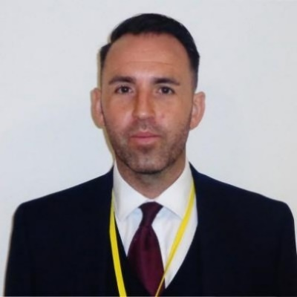
Speaker: Jorden Brewster, CFE, ACFS

Presentation:

Whistleblowing the key to unlocking the leadership door

Description: Learn what crucial role that whistleblowing played in the largest infrastructure project in Europe. Explore the highs, lows and pitfalls in the implementation of a whistleblowing framework in an unregulated, challenging industry.

Bio: Jorden Brewster is an experienced ethics and compliance professional, specialising in risk-based ethics and compliance programmes with a particular focus on bribery & corruption, fraud, whistleblowing, and investigations. He has extensive experience in leading complex and sensitive investigations in law enforcement with the Metropolitan Police and in the private sector across several industries including financial services, telecommunications and construction and engineering. As an Ethics & Compliance Officer, he has implemented multiple Ethics & Compliance programmes along with whistleblowing frameworks in large infrastructure projects.

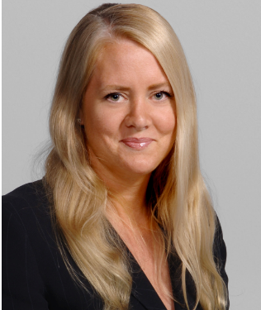
Speaker: Amanda Dupont, CAMS Thomson Reuters
Presentation:
Best Practices – Spotting and Stopping Identity Fraud
Learning objectives: Current types of identity fraud, and how fraudsters have adapted to pandemic changes, Challenges in detecting and stopping fraud, and how a proactive approach can mitigate those challenges, Examples of recent cases as well as tools you can integrate into your standard workflows, improve your risk management, and give you better visibility into customers and others, Interactive discussion with live chat to address your questions
Amanda has over 23 years of professional experience in the legal industry and is a highly experienced investigative researcher and nationwide speaker. She is a CAM-certified licensed attorney and practiced law in Minneapolis for over eight years before coming to Thomson Reuters. Amanda joined Thomson Reuters in 2006 and has held roles throughout the business. Since 2010, Amanda has worked exclusively in Thomson Reuters’ public records solutions. In her current role as Public Records Product Specialist, Amanda works closely with both Thomson Reuters’ customers as well as Thomson Reuters New Product Development team to help develop innovative solutions in the public records arena, including Thomson Reuters’ flagship Risk & Fraud solution, CLEAR.

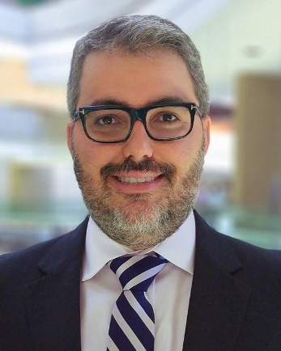
Speaker: Jorge Monteiro, CFE, MBA

Presentation: Lean Case Management

Description: Organizations have many challenges in managing their anti-fraud program, and some go beyond the execution of internal investigations and confidential reviews. This session will navigate through the different aspects of lean case management as a key component of the in-house investigations program, including how organizations can increase investigations agility and focus on value delivered to stakeholders.

Bio: Jorge Monteiro is Vice President of Special Investigations for GM Financial, responsible for the company’s in-house investigations program and governance activities, in support of General Motors ethics line. He has more than 20 years of broad international experience in fraud investigations, audit and compliance for Fortune 500 companies with a global footprint. He has specialized over the years in fraud examination, fraud risk assessment and management, anti-corruption and anti-money laundering, as well as operational and financial audits. He currently holds a CFE designation and is an ACFE mentor.

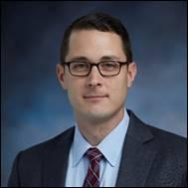
Speakers: Chris Ekimoff, CPA/CFF, CFE & Leo Munoz, CPA/CFF, CFE
RSM US LLP
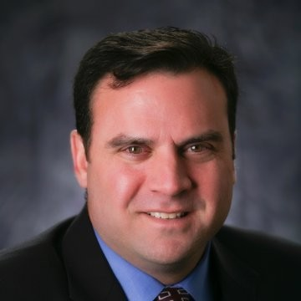
Presentation: “Into the Woods: Plotting a Course for a Successful Internal Investigation”
Description: In an internal investigation, it can be hard to see the forest for the trees. In this session, Chris Ekimoff and Leo Munoz, experienced forensic accountants and CFEs, will take a step back to look at the sources and objectives of internal investigations, explore strategies to position your company for the best possible outcome, and walk through a few recent cautionary tales (featuring some hot-button issues).
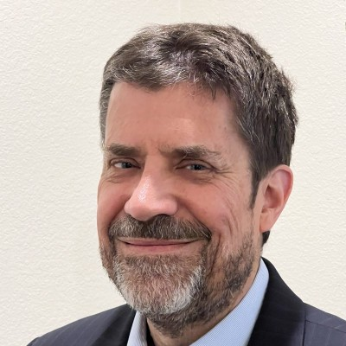
Bio: Christopher Ekimoff is a Director and the Southeast Region Leader in the Financial Investigations & Dispute Services Group of RSM US LLP.
Leo Munoz is also a Director for RSM in Financial Advisory Services. He has more than 25 years of accounting, finance, and management experience in public accounting, in industry, and as a business owner. He spent 6 years in public accounting in the audit department of a national public accounting firm, 9 years in various director-level financial positions with a publicly-held company, They have significant experience providing litigation consulting and forensic accounting services—including as an expert witness on behalf of clients—performing internal investigations, applying and evaluating financial reporting methods, responding to allegations of accounting and auditing malpractice, asset tracing engagements, and other complex financial and accounting issues. He is a co-host of the inSecurities Podcast from the Practicing Law Institute, and an Adjunct Professor at the Antonin Scalia School of Law at George Mason University. Chris also heads the FIDS Blockchain and Crypto Solutions Incubator at RSM.
Speaker: Keith Kahl, CFE, CPA, CIA, MBA, CGMA, CRMA
Founder and President of Kahl Professional Services LLC

Presentation: How to Ethically Succeed in Life, Investigations and Career
Description: Everyone wants to be successful. True and lasting success can only be achieved through ethical behavior. It is not just “what” you do to be successful, more importantly it is “how” you think, act, and communicate. In this presentation we will explore tips on how to be successful, each with its own ethical perspective.
Bio: Keith is President and Founder of Kahl Professional Services, LLC after a successful 40-year career in external and internal audit (22 years as a Chief Audit Executive), finance and accounting, and operations at global, multi-billion dollar, NYSE companies. Keith is now an Adjunct Professor at the University of Houston’s C.T. Bauer College of Business, performs external internal audit quality assessments, and is a guest speaker on success, leadership, and ethics. He also devotes time to helping those in need through various charity activities, active board member of Changing Young Children’s Lives through Education (CYCLE), advisory board member for Bauer College of Business Accounting Advisory Board and Chairman of University of Houston’s Bauer Executive Education Advisory Board. Keith has a BBA (Cleveland State University) and a MBA (DePaul University), and is a Certified Fraud Examiner, Certified Public Accountant, Certified Internal Auditor, Chartered Global Management Accountant and holds a Certificate in Risk Management Assurance.
Keith lives by a few mottos one being “there is no right way to do something wrong” and another being “find trouble before trouble finds you”.
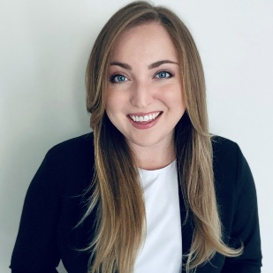
Speaker: Sophia Carlton, CFE
Title: Recession Strikes, Fraud Spikes: Recession-Proof Your Fraud Defenses
Description: There is a historic link between recessionary periods and spikes in fraudulent activity. Following a tumultuous few years, economies around the world are bracing themselves for a possible recession. What can you do to prepare today? In this session, we will cover the impact of a recession on fraud activity and explore methods you can leverage to recession-proof your fraud defenses.
Bio: Sophia is a Senior Manager in Accenture’s Fraud & Financial Crimes consulting practice, specializing in fraud strategy, fraud risk and maturity assessments, and fraud prevention solutions. She has spent the last 7+ years helping clients solve their toughest fraud challenges, with clients in both the public and private sectors – spanning from large complex federal agencies to Fortune 100 and 500 companies across multiple industries. Sophia is a recognized and award-winning fraud risk management thought leader; she has received two author awards and contributed as a lead author in the development of industry guidance used both in government and in the private sector. Sophia is a Certified Fraud Examiner (CFE) and holds a M.S. in Accounting from James Madison University.

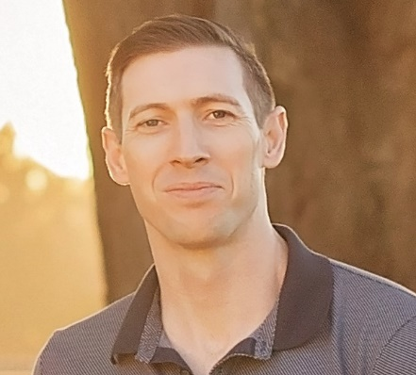
Speaker: Andrew Taylor, CFE
Veritas Technologies

Presentation: Reducing the Risk of Fraud in your Distribution Channel:
Description: For many corporations a distribution channel of third parties is the best, or only way, to get to their products to market. Channel distribution has many benefits including broadening your customer base, reducing overheads and boosting post-sales support. However, the channel can also increase your risks of corruption, bribery, and fraud. With the ever-present specter of the Foreign Corrupt Practices Act and various Trade Sanctions looming large over global corporations; internal compliance teams need to actively manage and reduce their third-party risks whilst balancing business needs and managing relationships with sales leadership. This session will discuss real world examples of controls used to reduce the likelihood of potential violations of the FCPA and trade sanctions while enabling the business to succeed.
Bio: Andrew Taylor is the Head of Ethics and Compliance for Veritas Technologies LLC, an enterprise software company based in Santa Clara. In this role Andrew supervises and undertakes investigations, instructs outside counsel, reports to the Audit Committee of the Board, manages enterprise-wide E&C training, and is responsible for the enterprise’s legal policies. Prior to relocating to TX in 2020, Andrew worked in Washington, DC and Santa Clara, CA. Andrew’s work experience includes practicing law for over 15 years, serving as an officer in the army, and representing New Zealand as a diplomat. In his roles he acted as a prosecutor, military attorney, and advised on intelligence operations and investigations. Advised on espionage, terrorism, and the proliferation of weapons of mass destruction.
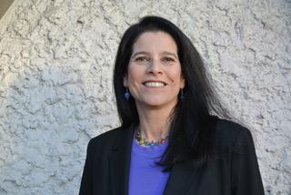
Speaker: Jessica Sanderson, J.D.
Volkov Law Group
Presentation: Anti-Corruption and Sanctions Compliance
Description: The DOJ has prioritized anti-corruption and sanctions enforcement. The administration elevated the importance of anti-corruption enforcement as a national security issue and is enforcing tough FCPA actions. Additionally, in response to Russia’s invasion of Ukraine, the US, along with its Allies and partners, have implemented a robust, global sanctions program designed to pressure Russia into retreating from its invasion. All of these initiatives have raised the risk of detection and circumvention of compliance and financial controls relating to anti-corruption and sanctions compliance. In this session, Jessica outlines key issues for proactive compliance efforts.
Jessica Sanderson, Partner at The Volkov Law Group, provides litigation, investigation, and legal and compliance advisory services to clients primarily in the areas of trade sanctions, export controls, and white collar crimes. Ms Sanderson has more than 25 years’ experience in private practice, as a litigator and as a leader on ethics and compliance monitorships. Ms. Sanderson has extensive experience working with clients and as in-house counsel in the evaluation, design, and implementation of effective ethics and compliance programs. Before joining the Volkov Law Group in 2019, Ms. Sanderson spent five years as in-house counsel at Innospec Inc. Among other things, at the Monitor’s insistence, Ms. Sanderson spearheaded a project to classify hundreds of products (chemicals) under U.S. and EU export control laws, and to substantially revise the Company’s export control and trade sanctions policy and program. Before that, Ms. Sanderson was a litigator who represented publicly traded clients in complex white collar and securities fraud investigations and litigation and served on FCPA compliance monitorships.
Speaker: Rick Roybal, CFE
Presentation: How a Leaky Password Shut Down a Pipeline
Description: The world’s infrastructure is under attack. Recent ransomware hacks of private and public entities are requiring organizations to prioritize the safeguarding of their assets and customers, as well as educating employees on cybersecurity risks. This session provides an overview of the Colonial Pipeline cybersecurity attack while also calling attention to the dangers of hacking organizations, such as DarkSide, on the world’s vital businesses.
Bio: Vendor risk management activist, consultant, author and speaker Rick Roybal has worked in the oil and gas industry for almost two decades. Roybal also serves as the president and chair of the Oil & Gas Vendor Roundtable and as the vice president of the ACFE Fort Worth Chapter. He has earned three degrees: B.A. Russian, M.A. linguistics and M.B.A. finance and accounting. Roybal is a Certified Fraud Examiner (CFE) and certified information systems auditor (CISA). His published work includes articles in “COPAS ACCOUNTS,” ACFE’s Fraud Magazine and IIA’s “Internal Auditor Magazine”.

Speakers: Robert Berry, Amanda “Jo” Erven
Amanda "Jo" Erven, CPA, CIA, CFE,
Founder of Audit. Consulting. Education. LLC.

Robert Berry – That Audit Guy
Presentation: Friday Fraudsters Live! Discussion

Description: We are friends that discuss fraud every Friday live on a LinkedIn podcast but THIS Friday we will be doing our show with you as the LIVE AUDIENCE! Get ready to hear some fun, some unique, some down-right-disturbing, fraud stories to be able to share with your teams. We will dissect the “how did this happen” for each story and give you the lessons learned to proactively prevent similar frauds in your workplace or personal life.
Bio: Amanda "Jo" Erven, CPA, CIA, CFE, is the President and Founder of Audit. Consulting. Education. Once in external/internal audit and accounting, Jo is now an active Internal Audit Strategist, Ethics and Culture Consultant, Higher Education Professor, Author, and Trainer/Speaker, providing Continuing Professional Education (CPE) hours, live and virtually, to organizations across the globe.
Bio: Robert Berry believes that curiosity is the strongest superpower we have. As a result, he asks a lot of questions. This curiosity helped him to become a successful chief auditor. Now, he has made it his mission to help others. He provides soft skills and technical skills training to fraud, risk, audit, and compliance professionals. He is an international speaker/trainer, author and has appeared in The IIA and Forbes magazines. Robert believes that his purpose is to help improve people, processes and profits.
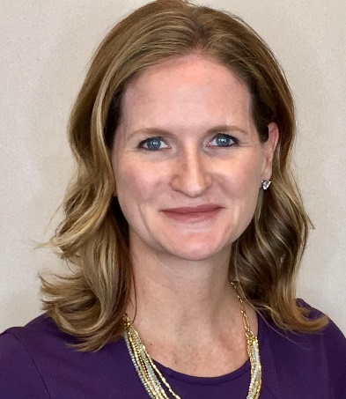
Speaker: Amy Nofziger, CFE
AARP
Presentation: Elder fraud: Changing the Narrative: Stop Blaming the Victim
Description: When a person is victimized by a scam, the victim is often portrayed as “falling for” something. This misses the part of the story of how skilled these criminals are at moving us to an emotional state, where our logical thinking takes a backseat. It also neglects how sophisticated many of these scams are. Ultimately, the culture of victim blaming is less about the sentiment of blame than it is about the words we use and practices we embrace.
Bio: Amy Nofziger is the Director of Victim Support for the AARP Fraud Watch Network and has two decades of experience in fraud prevention and victim support. While at AARP, Nofziger has led the AARP Fraud Watch Network Helpline, a nationwide toll-free helpline for anyone to report concerns about fraud. She also has collaborated on groundbreaking research, subjects include multi-level marketing enterprises, best Interventions for fraud and chronic victimization. She has worked with The New York Times, The Today Show, Live with Kelly and Ryan, Wall Street Journal, Good Morning America, and other outlets to help shed light on fraud and exploitation of consumers. She has a bachelor’s degree in criminology/sociology and Master of Arts degree with specialization in Leadership. She is a Certified Fraud Examiner.
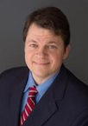
Speaker: Warren Rojewski, CPCU, CIFI, CFE, FCLS
Nationwide Insurance, Major Case Investigations Manager
Presentation: Fraud Indicators in the Self-Service World: email compromises, account takeovers and more
More companies are relying on digital and self-service solutions to sell financial products and insurance. Investigators must be aware of Red Flag indicators that did not exist 5 or 10 years ago and work closely with multiple different business units to capture, investigate, and resolve data discrepancies.
Warren has held several roles at Nationwide Insurance with increasing responsibility spanning 22 years including: Sr. Claims Representative, SIU Business Analyst, SIU Field Investigator, Major Case Consultant, Special Operations Consultant, and is currently an SIU Major Case Manager.
Bio: Warren has a wide breadth of knowledge in insurance operations, claims, data analytics, medical billing, complex medical claim investigations, and many forms of organized insurance fraud schemes.
Warren received his B.A. in Communications from Alma College in Alma, Michigan. He holds the CPCU, AIC-M, CFE, CIFI, AINS, AIS, ACLS, and FCLS designations and is completing the Associate in Risk Management designation. Warren resides in Michigan with his wife and 3 daughters. When he is not reading insurance books, he enjoys fishing in Michigan’s Upper Peninsula.

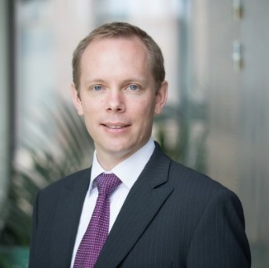
Speaker: Thomas Feray, CFE, CAMS
Vice-President Strategic Projects, “Action for Integrity”
Presentation: Creating and developing a culture of psychological safety and ethics for investigators
Description: Investigations can seem daunting within an organization and can create a heightened concern of retaliation for employees. During this session, Mr. Feray will convey how internal investigations can include employees at the center of the investigations process. Through employee feedback, investigators gain the best insight and accurate data while also being able to add a level of comfort and protection in the work environment for their fellow employees. The goal is to provide the attendees with an overview of a new approach of investigations (“holistic approach”), give some key points to reach it, and explain the benefits as well as the challenges which could be met, (2) explain how investigators may support employees who report a concern to feel safe and heard during the process, (3) explain how investigators may coach and support the management before, during, and after an investigation, and (4) explain how investigators may add value to the company (not “just” a cost center) by enabling psychological safety in the business.
Bio: Thomas Feray is a highly experienced investigator with extensive expertise in both the public (French Gendarmerie) and private sectors (SNC-Lavalin, Bombardier, and WSP Global). He is currently the Vice-President Strategic Projects for “Action for Integrity”, a Canadian-based company providing a safe space to facilitate connections between E&C Professionals.
Thomas Feray holds a master’s degree in Business Law, with a specialization in Compliance, and is both a Certified Fraud Examiner (CFE) and a Certified Anti-money Laundering Specialist (CAMS).
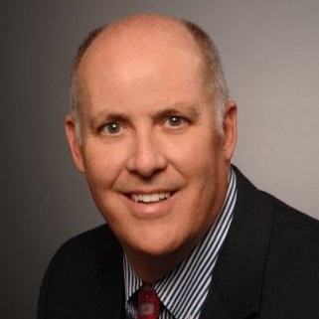
Speaker: Dan Ramey, CPA/CFF/ABV/CITP, CFE, CVA, CIA/CRMA, CISA/CISM, CMA,
Founder and President of Houston Financial Forensics
Presentation: “Cryptocurrency fraud”
Description: Cyber fraud, cybersecurity, and cryptocurrencies are three of the hottest topics in business discussions today. Join Dan Ramey, CFE to learn what is going on in the world of cyber fraud and cryptocurrencies. The discussion will include what are some of the newest cyber fraud schemes occurring and an introduction to cryptocurrencies and how they are utilized in cyber fraud schemes.
Bio: Dan is the Founder and President of Houston Financial Forensics, LLC and Dan T. Ramey, CPA, LLC. Dan is a frequent speaker to business and professional groups on fraud, cyber security / cyber fraud, risk assessment, third-party risk management, fraudulent financial reporting, internal audit, COSO 2013, valuation methodology, compliance, and due diligence. Dan was recently awarded, Educator of the Year by the Houston ACFE Chapter for his teaching at University of Houston, Bauer College of Business.
Houston Financial Forensics, LLC is a professional services provider in the areas of fraud investigation, cyber security/cyber fraud risk assessment, forensic accounting, fraud risk assessment, internal audit, internal controls design and implementation, business valuation, litigation support, third-party risk management services, internal audit department quality assurance reviews, SOX 404 services, and due diligence (buy-side and sell-side) for mergers and acquisitions.
Dan is a graduate of Baylor University with a degree in Accounting and an Executive MBA from Houston Baptist University.

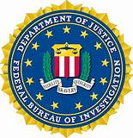
Speakers: Shelby Janysek and Dimitri Willis
Forensic Accountant and Special Agent, FBI
Presentation:
Business Email Compromise Investigation; United States vs. Kenenty Kim

Description: An explanation of various types of business email compromises followed by case study of how the FBI investigates a BEC case.
Bio: Shelby graduated from the University of Tennessee at Chattanooga with a dual major in Accounting and Finance and joined the FBI as an Operational Support Technician (OST) in Houston. I was very interested in the position of a Forensic Accountant (FoA) and enrolled in the FBI’s FoA Academy in 2017 where I was paired with a mentor who would begin teaching me the job duties and escorting me to various meetings and court proceedings. I moved to the Bryan RA in June 2018 and supported the Criminal squad as well as the Counterintelligence/Counter Terrorism squad as an OST but was able to continue with the FoA Academy. I also continued to study at night, and I graduated from Concordia University with my MBA in Accounting. This led to me becoming an FoA in April 2020. Some of my job duties include issuing Federal Grand Jury Subpoenas and reviewing the returns, analyzing and organizing this information, creating summaries and visuals, providing support for potential indictments and trials, and ultimately testifying to my findings and work in court. Additionally, I am an evidence technician for the Bryan RA. I receive, store, and ship evidence for the FBI and will occasionally join the agents on evidence searches. I handle general evidence as well as drugs, valuables, digital items, and firearms.
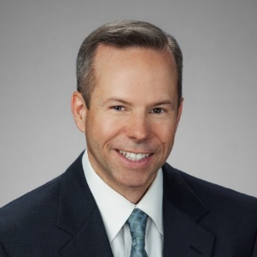
Speaker: Paul Pettit, Vice President, Revenew International
Presentation: Construction Fraud: You Make the Call

Description: Construction fraud has been around a long time. Some schemes are simple and some are very complex. In today’s post pandemic and inflationary environment, we have seen a significant increase in fraud from falsifying payment applications to billing for underperformed work. Construction fraud has affected both public and private companies, including many businesses building projects around the globe. The fraud card is difficult to play but auditors need to step up and accept the challenge to audit their companies’ construction projects and look out for fraud.
Bio: With over 30 years of progressive roles within industry and professional services, Paul managed and delivered successful audit and consulting projects to clients across a multitude of industries, He leads the Performance Improvement practice and oversees business development, account management for clients seeking cost recovery and containment, improvements both with external and internal parties.
Since 1999, Paul has been involved in providing consulting and internal audit services within technical areas of organizations including engineering, procurement, and construction. Previously, he worked for over 9 years in the Engineering, Procurement and Construction (EPC) industry with a Leading contractor. Paul holds master’s degrees in business and Environmental Management, a bachelor’s degree in civil/Mechanical Engineering Technology from the University of Houston. He is certified as a Project Management Professional (PMP), Construction Controls Professional (CCP), Construction Auditor (CCA), Internal Auditor (CIA), Risk Management Assurance (CRMA) and Professional EH&S Auditor (CPEA).

Speaker Marta Cadavid, CAMS, CFE, CHTI, AMLCA
Founder and Managing Partner of NOFRAUD LATAM LLC

Presentation:
Using the Fraud Triangle Analytics to predict, prevent and detect misbehaviors.

Description: Fraud, corruption, waste, corporate abuse, and other misconducts destroy the organization's value; in other words, they are the silent enemy that kills the companies. ​We​must​ anticipate or be one step ahead of the employees’ misbehaviors knowing that a large % of people act according to the moment, situation, or crisis. It means, organizations deal with a high and permanent risk. Through the fraud triangle theory with AI, data analytics, and semantics, it is possible to identify risks in human communications.

Bio: Marta brings more than 25 years of experience in strategic financial management and accounting, internal auditing, fraud investigation and compliance in different kinds of industries such as financial services, trading, pharmaceutical, transportation, oil & gas, and retail. As a consultant, Marta helps people and corporations to fight misconducts that destroy the organization’s value such as fraud, waste, financial abuse, corruption, among others.

Marta is a​ proud​ co-developer of The Fraud Explorer, a unique software to monitor misbehaviors in ​the​corporate environment in real time. In addition, Marta is an international coach and ethics advocate with special knowledge of the Latin America corporate culture who designs and delivers comprehensive training and tools to equip individuals and organizations with skill sets and effective framework of risk management, internal controls, compliance, and auditing including Money Laundering and Terrorism Financing, Risk Management System, Fraud Risk Management COSO 2013, and Due Diligence.

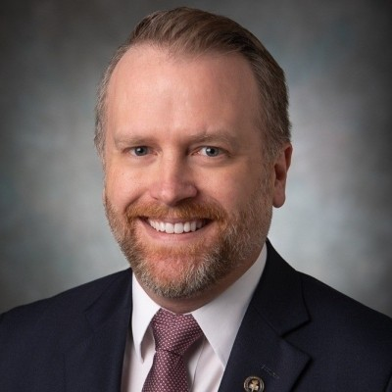
Speaker: Jason Zirkle, CFE

ACFE (Association of Certified Fraud Examiners)

Presentation:

A Case Study in Ethics and Embezzlement

Description: We will discuss ethics, with a focus on understanding the mindset of the fraudster. Then, we will go through a real-life criminal case study from the files of the Texas Rangers. This case involved an unusual multi-million-dollar procurement fraud, reverse kickback scheme, and embezzlement at a large public university in Texas. In the case study, we will focus on the mechanics of the investigation, and how ethical issues and failures in internal controls and the audit process ultimately led to the fraud.
Bio: Jason Zirkle is the Training Director for the Association of Certified Fraud Examiners (ACFE). At the ACFE, he conducts training presentations around the world on a variety of fraud-related topics. Prior to joining the ACFE, Mr. Zirkle was a financial crimes analyst with the Texas Ranger division of the Texas Department of Public Safety, where he served as a subject matter expert on financial crime. Working alongside Texas Rangers, he supported numerous cases involving fraud and money laundering, public corruption, embezzling, identity theft, illegal gambling, and other white-collar crimes. He also provided financial expertise to non-financial criminal investigations, including multiple murder investigations, human trafficking, narcotics, and missing persons. He has testified in multiple criminal trials and grand juries.
Prior to working with the Texas Rangers, Mr. Zirkle was an intelligence analyst for eight years in the U.S. Army, with combat deployments to Iraq and Kosovo.
Mr. Zirkle graduated from Texas State University with a bachelor’s degree in Criminal Justice. He also served on the Board of Directors for the Central Texas Chapter of ACAMS, the Association of Certified Anti-Money Laundering Specialists.

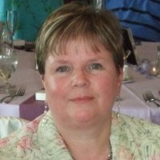
Speaker: Dawn LeCrone, CAMS, Compliance Consultant, Nationwide Insurance

Presentation: Elder Fraud as Financial Crime, Case Studies and Best Practices
Bio: Dawn currently works with Nationwide Financial, a division of Nationwide Insurance (“Nationwide is on your side.”) and has worked there for 24 years. She is a consultant, Corporate Compliance, Financial Crimes and Sanctions office. A graduate of Otterbein University, Dawn has worked in a variety of positions within the Financial Crimes and Sanction office at Nationwide until she began her current role in 2021.
Dawn has a passion for preventing and, when necessary, investigating elder fraud. She works on cases where there are suspicious withdrawals, often attempts to persuade individuals that they may be victims of fraud, advocates for individuals and family members when circumstances appear questionable and refers investigations to the appropriate legal authorities where necessary. Dawn is persistent and passionate about safeguarding customers’ assets and annuity funds.

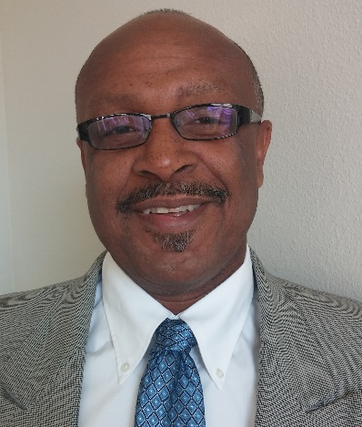
Speaker: Oscar J. Harvin, PhD, CPA, CFE
Assistant Professor, Accounting, Sam Houston State University
Presentation: Is Robin Hood Just a Fairy Tale?
Description: Less is known about the rationalization element of Donald Cressey’s Fraud Triangle than the other elements. It is difficult to know exactly what the mindset of an individual is that allows him or her to justify criminal behavior. The audience will be provided a unique experience to gain insight pertaining to the mindset of an individual that decides to commit an embezzlement that contradicts his moral foundation under normal circumstances. Gernado Abram, who perpetrated an embezzlement of over $650,000 from his employer, cooperated in the study of this fraud. He allowed researchers to interview and even video his discussion of the crime that he committed. Attendees will be taken on a journey in which he transforms from being a highly moral based individual to being an embezzler that perceives his actions more as a “Robin Hood” undertaking rather than a criminal act.
Dr. Oscar Harvin is an assistant professor of accounting at Sam Houston State University. He obtained his PhD from Florida Atlantic University and is a certified public accountant, certified fraud examiner as well as a licensed private investigator. His academic research examines the various factors that impair the ability of auditors to detect occupational and financial statement fraud. Another objective of his research is to inform both academicians and practitioners of the various fraudulent schemes that are being conducted by criminals. Dr. Harvin’s primarily teaching interest is in fraud examination and auditing but is also experienced in teaching income tax related courses.
He has over two decades of auditing and fraud related professional experience. His expertise in conducting investigations from a financial perspective was developed during his many years as a Special Agent with the Criminal Investigation Division of the Internal Revenue Service. During his years as a special agent, he investigated crimes that involve tax fraud, Ponzi schemes, child pornography, domestic terrorism, money laundering and other criminal activities. Professor Harvin leverages his vast professional experiences to prepare students for careers that involve fraud examination such as auditors, investigators, cyber security, law enforcement and other fraud related careers.

